LVM Session 2 Summary :

- If we want to extend the LV then we need space in that same VG.

- If we don’t have space in VG and we want to extend the space of one of LV then we have 2 ways,
- Extend the VG using add more HD
- Reduce one of LV size and give back to VG and give that space to another LV.

- As we already have 2 LV of size 60 GiB and 39 GiB and we store some data in both hard disks.

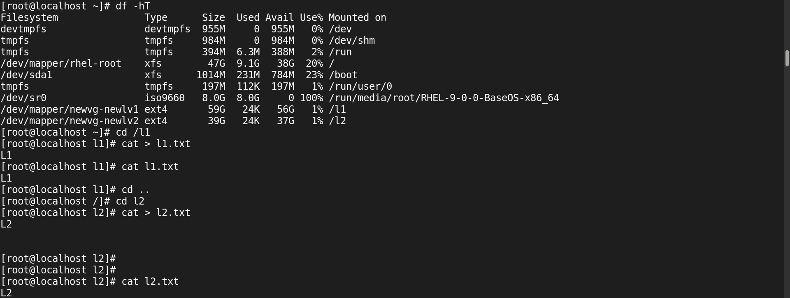

- We don’t have space in VG and still we extend LV then it will show error.
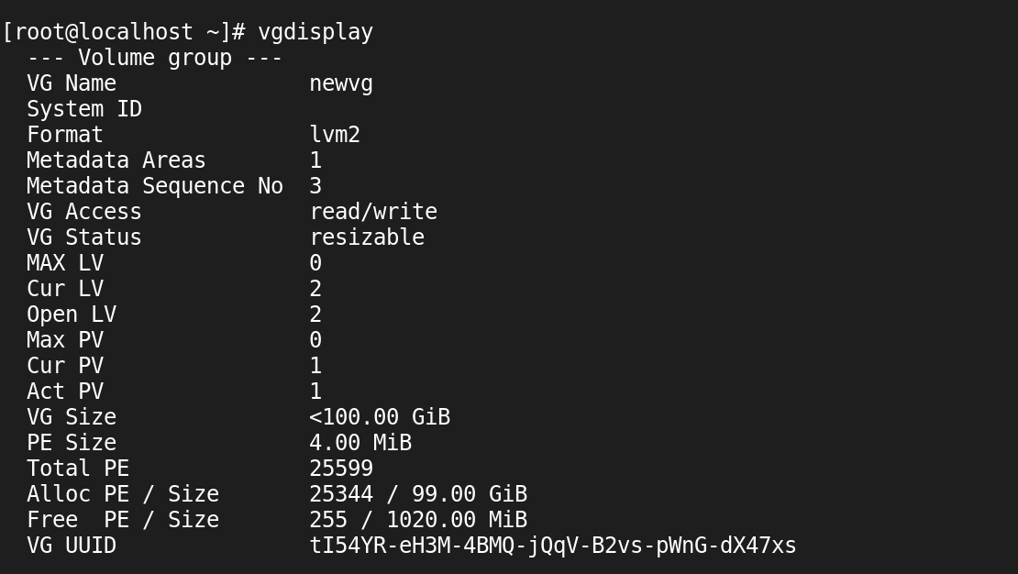

- If we want to reduce space from LV then we have to follow 5 steps:
- If HD is online then we have to first unmount the partition using umount command.
- Then we have to clear/clean garbage from that partition.
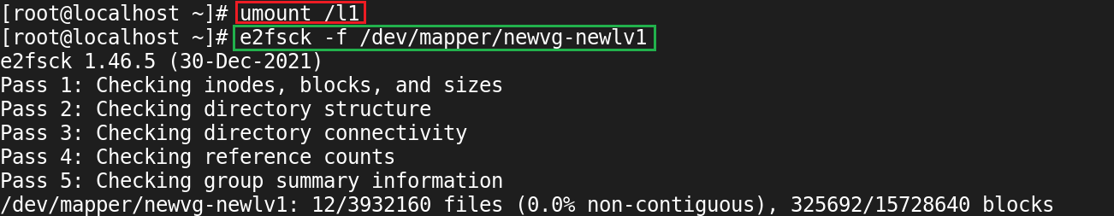

- Recreate Inode table for some space. Eg. If we have a total 60 GiB space and 50 GiB space we want and 10 GiB space we give back to VG then we need to recreate an inode table for 50 GiB.

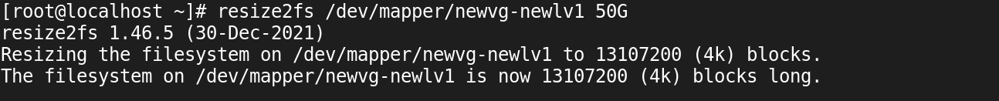

- Reduce the actual physical space from that LV and add to the VG.

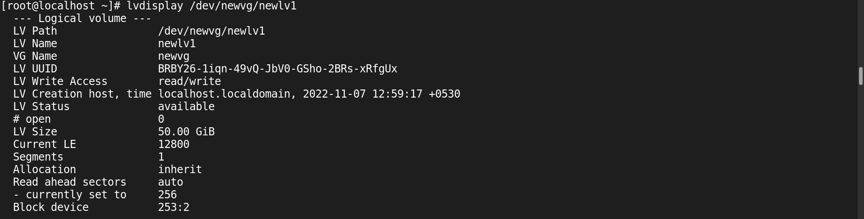
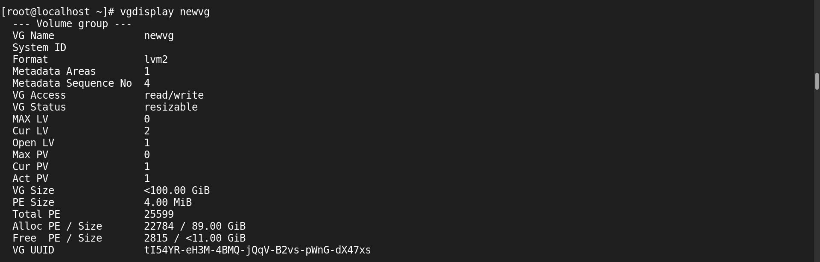

- Then again mount that partition to the folder.

- After getting space into the VG now we can extend LV using the lvextend command and format that extra space using resize2fs command.

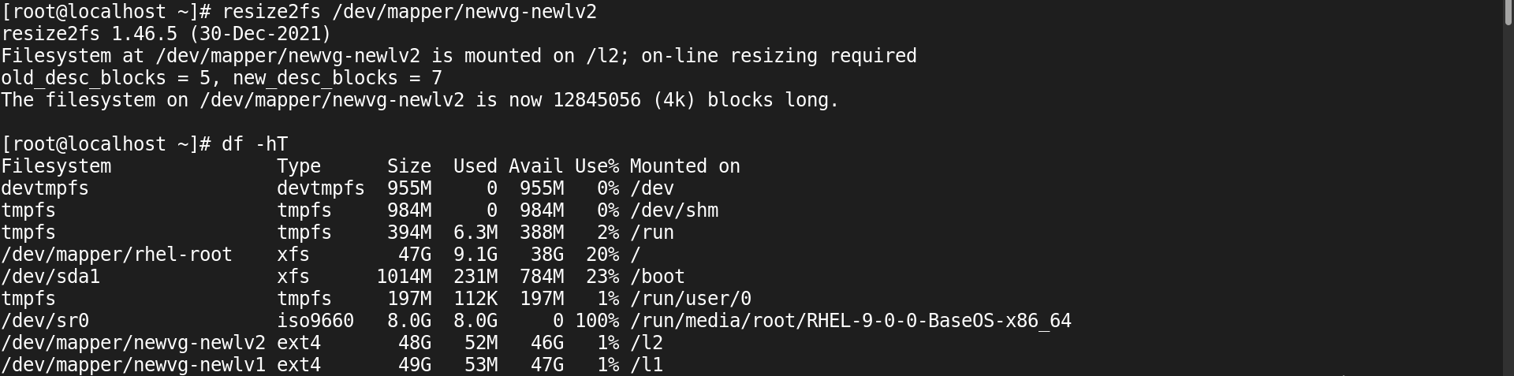

- In RHEL we have multiple format types such as,
- ext4: As we already see the resize2fs command. It will be used to both, extend and reduce space.
- xfs : Like resize2fs command we used xfs-growfs command in xfs format type. But here we only used this command to an extend.

- As we see in hard disks we store data in terms of sectors. Like here we store data in blocks and that block is known as Physical Extend(PE) in PV and Logical Extend(LE) in LV. By Default that PE or LE size is 4 MiB.

- If we create a LV of size 6 MiB then it will automatically create 8 MiB(Multiple of 4 MiB).

